BrAve Forms Review 4/7/25

**Dashboard –**

All Tabs across the top of the page work correctly

Clicking on a folder icon in the recent projects box dose nothing. Clicking on this icon or the project name should take you to the project page for that project

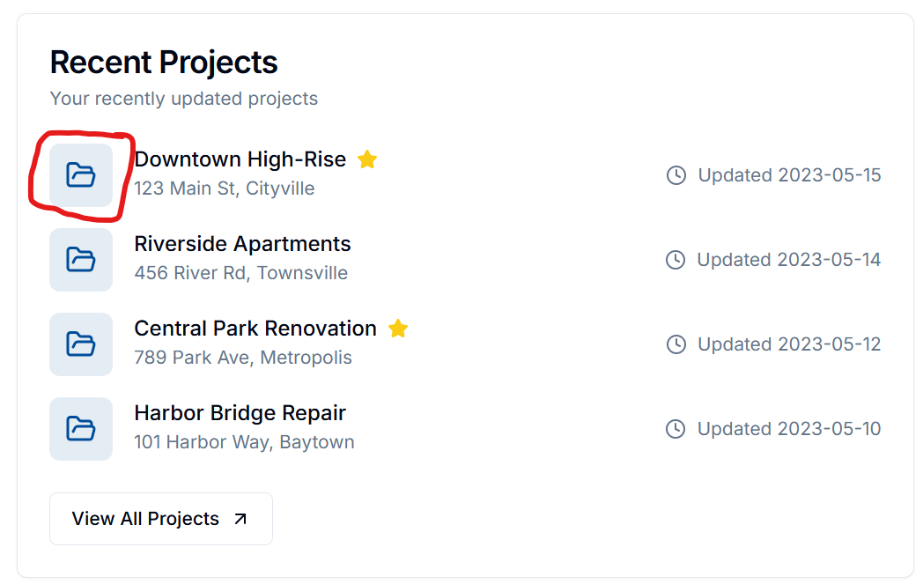

Clicking on a log icon or the log name in the recent log box dose nothing. It should take you to the page for that form

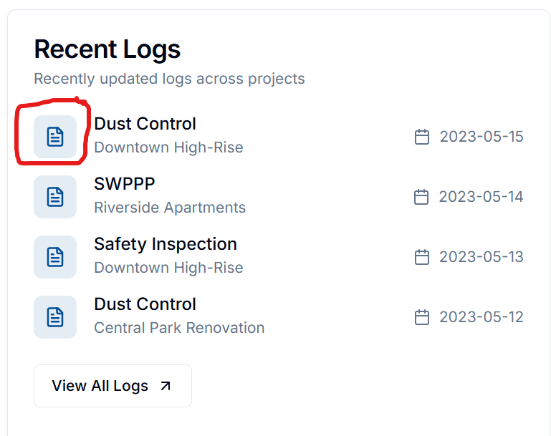

Should Recent Logs be renamed Recent Forms to match other area?

**Projects Tab –**

Would like to see the option to change view to a list view

The Projects on the top row look of when you click on view project but the one the bottom row show up as Project 5, Project 6, ….. instead of using the actual project name and when you click on the view forms in the project it takes you to the forms the Downtown High-Rise project

**Inside a Project –**

Should the title or icon in the analytics at the top of the layout be a link to the reference items?

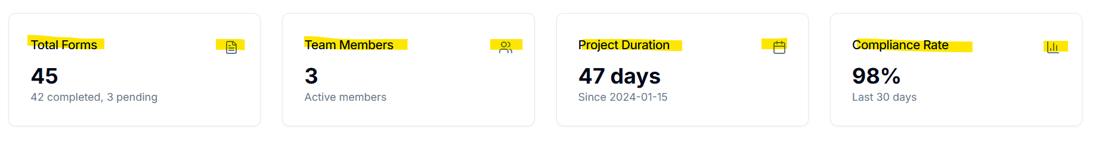

**Form Details –**

Edits to forms are not saving

Form history box shows there is history the day before and the day after but there were no forms created on those days

**Project Forms –**

When in open Project Forms for Downtown High-Rise I see (5) forms

* Dust Control 2/28/24 & 3/2/24
* Safety Inspection 2/29/27
* SWPP Inspections 2/25/24 & 3/1/24

When you view a form - Dust Control Log dated 2/28/24 for example, the Form history shows forms for 2/29 and 3/1. I don’t think these exist and when you click on the View options nothing happens?

Project Forms box shows Dust Control Logs dated 3/2/24 & 3/10/24 and Safety Inspections 2/29/24 & 3/15/24 note that the 3/10/24 Dust Control and 3/15/24 Safety Inspection forms do not show up in the list of forms on the previous screen. The two SWPP Inspection Forms are not listed at all in the box

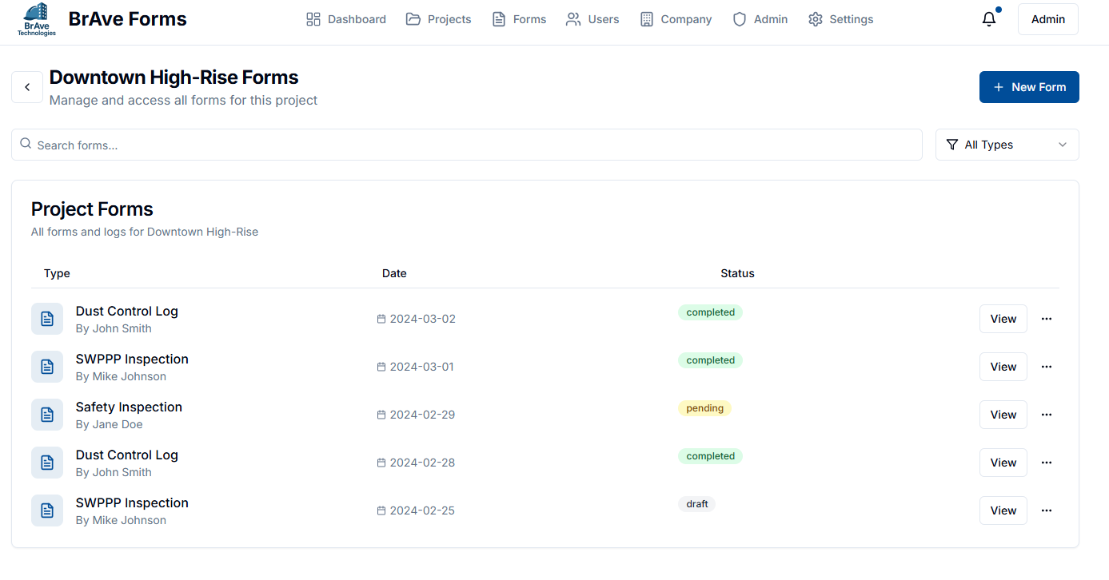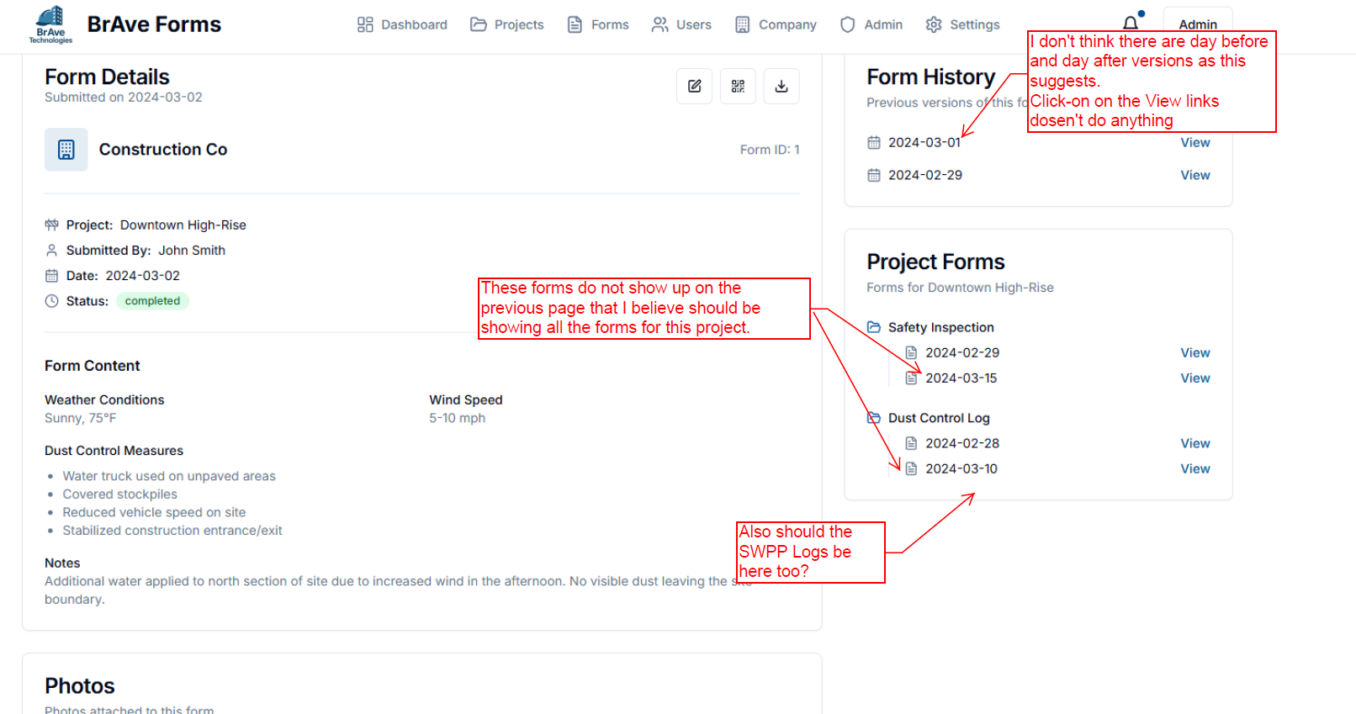

Edits are not applying when I make a change to the form and save it.

When viewing a form in a project clicking the back button takes you to the Forms tab not the forms for the project you are viewing

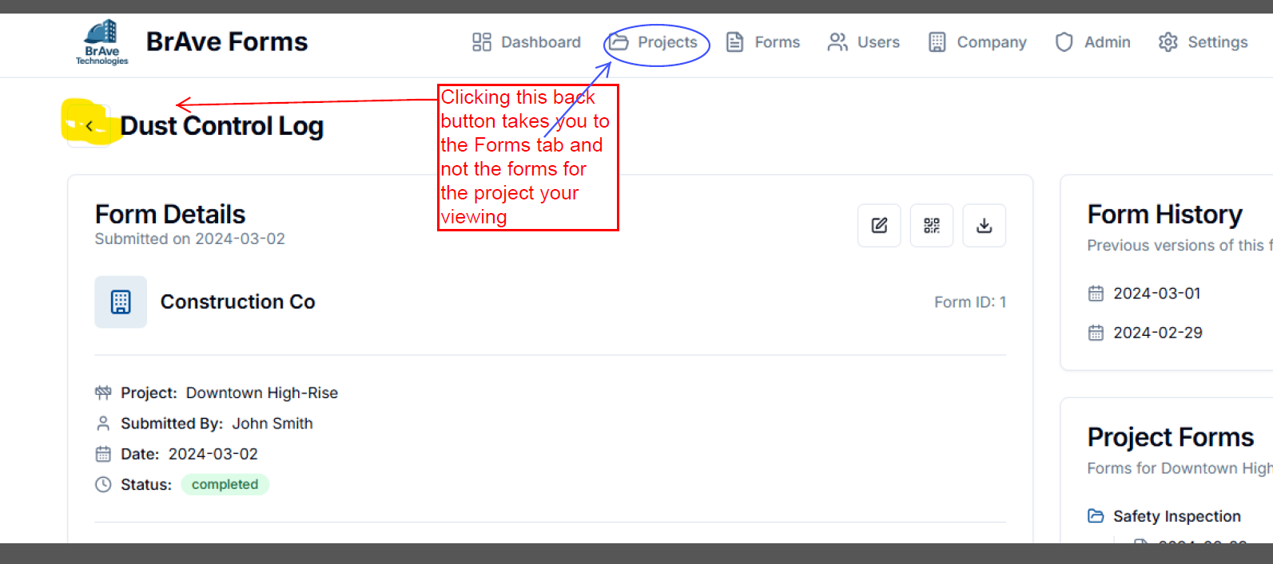

Creating new forms is not working correctly

I created a dust Control form on 4/8/25 and now it is the only form that shows up in the Forms Tab.

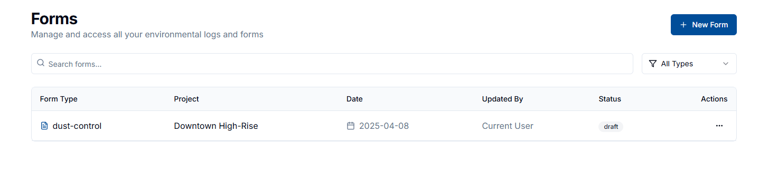But when I click on it to view, it shows me the form from 3/2/24.

When creating a New Form, the drop down menu for Select Project shows only 3 projects, should show all active projects

**Projects –**

I created a new Project (Breen Remodel) and now it is the only project that shows up in the Projects Tab and when I click on it to see the details it shows me the Downtown High-Rise